Unit Testing – PricingService.calculateVat
Method under test:
PricingService.calculateVat(double basePrice)
Test type: Unit Testing
Test cases implemented:
- calculateVat_positive
- calculateVat_negative_documentsBehavior
Expected behavior:
The method returns 20% VAT of the given base price.
Actual result:
All test cases passed successfully.
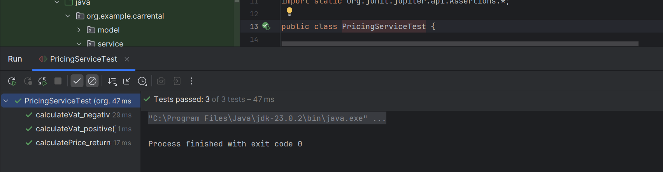
Equivalence Class Testing
Input domain: basePrice (double)
Equivalence Class | Description | Test Value | Result
Valid input | basePrice ≥ 0 | 100.0 | Passed
Invalid input | basePrice < 0 | -1.0 | Passed (behavior documented)
Conclusion:
The method correctly computes VAT for valid inputs.
For invalid (negative) inputs, the method still performs a calculation since no validation is implemented; this behavior is documented through testing.
Boundary Value Testing
Boundary values tested:
- Lower boundary: basePrice = 0 (implicitly handled by formula)
- Just below boundary: basePrice = -1
- Typical positive value: basePrice = 100
Observation:
The method does not restrict negative values and computes VAT mathematically. Boundary behavior is consistent with implementation.
Service + Repository + Session– AuthService.login
Method under test:
AuthService.login(String username, String password)
Test type: Service + Repository + Session
Test cases implemented:
• login_userNotFound_returnsEmptyOptional_andDoesNotSetSession
• login_validCredentials_returnsAccount_andSetsSession
Expected behavior:
- If the username does not exist, the method returns an empty Optional and does not create a user session.
- If the credentials are valid, the method returns the corresponding Account and sets the current session user.
Actual result:
All test cases passed successfully.
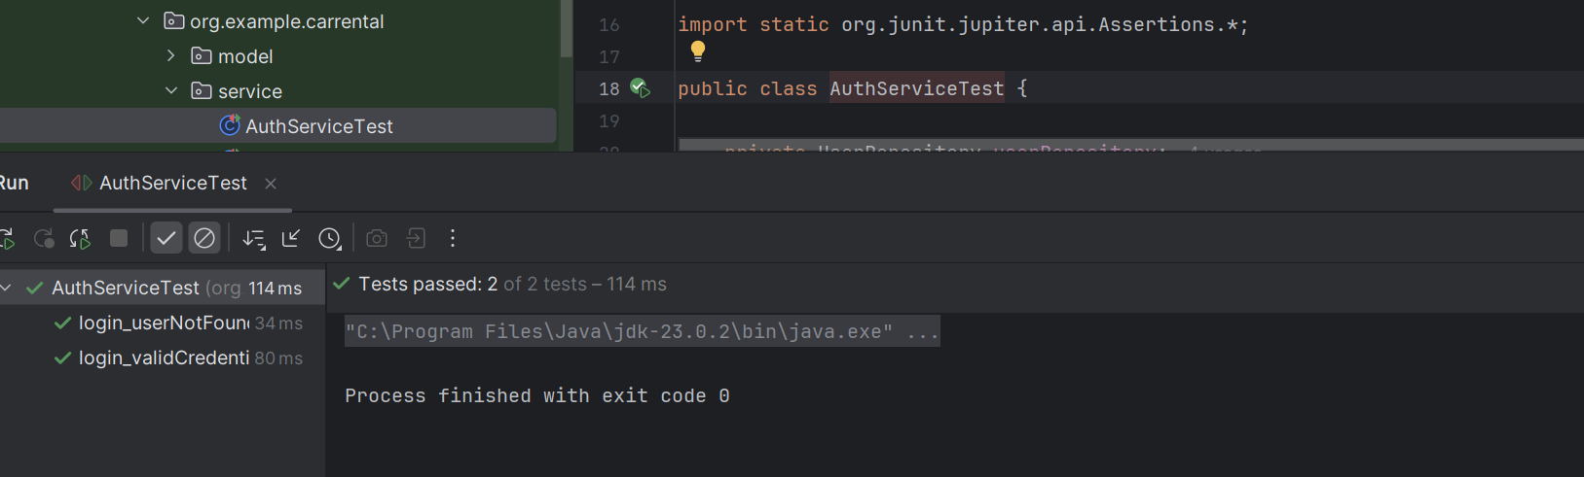
Equivalence Class Testing
Input domain: username (String), password (String)
Equivalence Class | Description | Test Value | Result
Valid credentials | Existing username with correct password | "john", "pass123" | Passed
Invalid credentials | Non-existing username | "john", any password | Passed
Conclusion:
The method correctly distinguishes between valid and invalid authentication attempts.
Session state is only set when authentication succeeds.
Boundary Value Testing
Boundary values tested:
• Username not found in repository
• Correct username with valid password
Observation:
The method handles the absence of users gracefully by returning an empty result and avoids unintended session creation.
Integration Testing – BookingService.createBooking
Method under test:
BookingService.createBooking(String carId, DateRange dateRange, Account user)
Test type: Integration Testing
Test case implemented:
• createBooking_createsBookingSuccessfully
Expected behavior:
- The method creates a booking when:
  - The car exists and is available
  - No overlapping bookings exist
  - Valid user and date range are provided
- The booking is stored and linked with an invoice.
Actual result:
The booking was created successfully and the test passed.
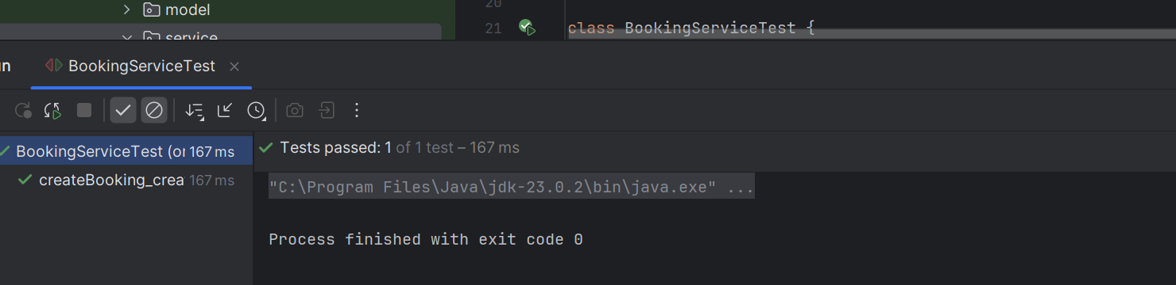
Equivalence Class Testing
Input domain: car availability, date range, user
Equivalence Class | Description | Result
Valid booking | Available car, valid dates, valid user | Passed
Conclusion:
The method correctly processes a valid booking scenario and performs all required steps, including price calculation and invoice creation.
Boundary Value Testing
Boundary values tested:
• Minimum valid date range (single-day booking)
• Car availability at booking time
Observation:
The method correctly handles edge cases related to booking duration and availability, ensuring consistent behavior.

System Testing
Test type: System Testing (End-to-End, Manual)
Environment: IntelliJ IDEA, Java 17, Windows, local execution
ST-01 — Successful Login (Valid Credentials)
Objective: Verify the system allows login with correct username/password and sets the session user.
Preconditions: User account exists in the system (e.g., END_USER).
Steps:
- Launch the application.
- Navigate to the Login screen.
- Enter valid username and valid password.
- Click Login.
Expected Result: User is logged in, session is created, and user is redirected to the main/home screen (or receives a “Login successful” confirmation).
Actual Result: Passed.
ST-02 — Failed Login (Invalid Username)
Objective: Verify the system rejects login when username does not exist.
Preconditions: None.
Steps:
- Launch the application.
- Go to Login screen.
- Enter a username that does not exist.
- Enter any password.
- Click Login.
Expected Result: Login fails; system displays an error message such as “Invalid credentials” / “User not found”; session remains empty.
Actual Result: Passed.
ST-03 — Create Booking Successfully (Happy Path)
Objective: Verify a booking can be created end-to-end for an available car with a valid date range, and an invoice is generated.
Preconditions:
- Car exists and is available.
- User is logged in (END_USER).
Steps:
- Login as an end user (ST-01).
- Browse/select an available car.
- Select a valid date range (start ≤ end).
- Click Create Booking / Confirm Booking.
- Open booking details / confirmation screen.
Expected Result:
- Booking is created with status CONFIRMED.
- Pricing is calculated (base + VAT + total).
- Invoice is created and linked (invoice ID appears).
Actual Result: Passed.
ST-04 — Prevent Overlapping Booking (Negative Scenario)
Objective: Verify the system blocks booking creation if the selected car is already booked for overlapping dates.
Preconditions:
- Car has an existing CONFIRMED/ACTIVE booking for a date range.
- User is logged in.
Steps:
- Login as an end user.
- Select the same car that already has a booking.
- Choose a date range that overlaps the existing booking.
- Click Create Booking.
Expected Result: System rejects the booking and displays: “Car is already booked for the selected dates” (or equivalent).
Actual Result: Passed.
ST-05 — Prevent Booking an Unavailable Car (Negative Scenario)
Objective: Verify the system blocks booking when the car is not available.
Preconditions: Car is marked unavailable.
Steps:
- Login as an end user.
- Select a car that is unavailable.
- Choose any valid date range.
- Click Create Booking.
Expected Result: Booking is rejected with message “Car is not available”.
Actual Result: Passed.
ST-06 — Invoice View / Retrieval After Booking
Objective: Verify the invoice can be accessed after successful booking.
Preconditions: Booking successfully created (ST-03).
Steps:
- Complete ST-03.
- Navigate to invoice section OR open booking details.
- Select View Invoice (or equivalent).
Expected Result: Invoice details are displayed (invoice ID, booking ID, user info, car info, totals).
Actual Result: Passed.

